Investment Summary

SIG Combibloc Group AG(SW:SIGN)
Target Price: 27.61

Value Investment with untapped growth potential – Initiated with a BUY

SIG Combibloc Group (SIG) has presented a fundamentally strong nine month’s performance with an equally promising fouth quarter. Despite headwinds from increase in higher input costs including aluminium prices, energy cost and capex, strong revenue growth led improved profit margins has reaffirmed the trust on the financials of the Company. With an underling strong business model, potential of market growth in aseptic packaging market and an environmentally sound alternative to PET Bottles, the product has considerable scope for improvement and capturing the market. Based on eh detailed financial analysis, this report terms the stock as a value investment and with the current prevailing market price, it will prove to be a decent entry point for prospective investors.

- Fundamentally strong Company with sustainable product offering
The financials of the Company had been sluggish up until 2018 after which the growth trajectory for the financials of the Company revived. For FY21, the company as reported pretty strong performance at the topliner as well as the bottom-line levels. More importantly, the product offered by the Company is the need of the hour given the growing consciousness of the business community towards sustainable packaging and reduction in climatic impact via lower carbon footprint. The company offers a sustainable and economical alternative to infamous PET bottles with significant plastic wastes. This places the Company high in ESG matrix and hence, provides a reason to believe in group’s future.

- Strong No 2 Position in a high potential market
The Company comes second only to the market leader i.e., Tetra Pak. With considerable barriers to entry, SIG is expected to continue improving its market share while retaining its number two title. Given the strong market potential, being on the better side of the learning curve might prove beneficial in the near term to long term basis. This report bets on more than proportionate increase in market share as the overall size of the pie increases (and not just SIG’s share in the existing pie)

- Strong business profile with valued customer base
Given is legacy presence, the Company has long standing partnership with a diversified set of clients. Many of such clients are blue chip companies spread across the APAC, EMEA and Americas regions. The top 10 clients have more than 25 years of vintage relationship with the Company which guarantees that increases the entry barriers. Continued investment in acquiring strategic competitors along with continued stress on the R&D side makes the Company as value stock.

Market Data |  | Share Price | Recommendation
As on 01.12.2021 |  | 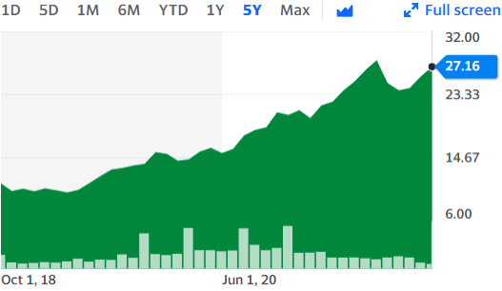 | 
Currency | CHF
Price | 25.00
52-Week High | 28.56
52-Week Low | 19.20
Market Cap | 9.167 B |  | Target Price
Free Float |  |  | Upside Potential | Buy
Performance (non-annual): |  |  | Downside Potential | Sell
1 month | + 5.76% |  | In Between | Hold
3 months | - 2.37%
12 months | + 39.07%

Business Description
SIG Combibloc Group AG (the "Company," ticker: SIGN: SW) produces aseptic carton packaging systems and solutions for beverage and liquid food products. In addition to replacement parts, maintenance, digital, add-on, training, and other services, SIG offers aseptic carton packaging filling machines, aseptic carton packaging sleeves, and closures. The firm has over 5,900 employees globally and operates largely in Europe, the Middle East, Africa, Asia Pacific, and the Americas. SIG is the world's second-largest manufacturer of aseptic carton packaging systems, primarily serving the liquid dairy (milk, curd, and cheese & cream products) and non-carbonated beverage (cold drink, juice, and cold coffee) industries. The firm was established in 1853 and is based in Neuhausen am Rhein fall, Switzerland, manufacturing weapons then shifting to manufactured packaging machines in 1906.
SIG Combibloc Group AG was acquired by Onex in 2015, they have had their RE-IPO in September 2018 at 11.25 per share. They have seen continuous growth and share price more than doubling. They are continually developing new aseptic packaging technologies that allow drinks and liquid foods to keep their flavor, appearance, and nutritional properties for up to 12 months without refrigeration or preservatives. SIG collaborates closely with its customers to offer safe, sustainable, and affordable food and beverage products to people all around the world. SIG reported sales of €1,457.6 million in the first nine months of 2021, up 13.1 percent. According to their annual report for 2020, they have 1,266 SIG filling equipment in the field in over 60 countries. The sleeves and closures accounted for 86% of the income, while filling lines and the service of the organizations' deployed filling lines accounted for the remaining 14%.
Regional Sales: SIG's regional sales were concentrated in Europe, the Middle East, and Africa (EMEA), which accounted for 50.3 percent of total revenue in FY20, followed by Asia Pacific (APAC) (34 percent), and Americas (13 percent) (15.7 percent). EMEA provided 48.8% of EBITDA, APAC 38.3%, and Americas 13% in FY20, according to EBITDA. SIG has continuously been expanding on areas outside of EMEA, in 2010 68% of their revenue generated came from EMEA and now, only 45% of the revenue is from EMEA despite the revenue volume only increasing over the years.
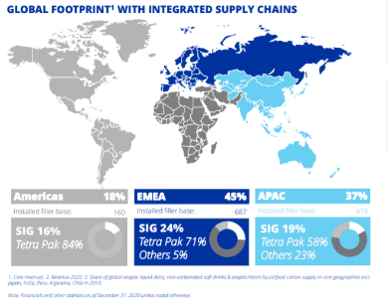
Huge consolidated market position, competitiveness in some areas: SIG has few worldwide competitions since it is one of only two main global companies in the aseptic carton packaging sector. Most clients sign long-term contracts with both Tetra Pak (TP) and SIG, mostly to avoid being reliant on a single supplier, to gain some price negotiating leverage, and to gain more access to newly available forms.
Further expanding the geographic footprint: The Company is committed to extending its operations internationally; revenue diversification was in line with FY20 objectives and is projected to be bolstered by the company's recent planned acquisitions, which will give it a larger geographic footprint in the region with promising growth prospects. The purchase of Visy Cartons in late 2019 was a notable contributor to growth, contributing 260 basis points to constant currency core sales growth in 2020.
Experienced Management: In the packaging (manufacturing) area, SIG has a competent management team. Samuel Siegrist (CEO, President & Executive Director) currently leads the company, having previously served as SIG's CFO and succeeding Rolf Stango in January of this year. SIG's management team includes a number of such capable professionals with extensive expertise and a track record in sustainable development, product design and innovation, execution and operational efficiency, and seamless supply chain management.

Industry and competitive positioning
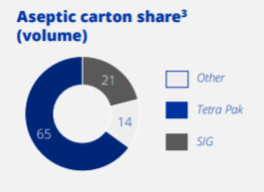
Concentrated market (with 86% market share consolidation at top) and fragmented at the tail: The aseptic carton packaging industry is concentrated at the top, with two big competitors, Tetra Pack (leader with 65 percent) and SIG (21 percent), capturing 86% of the market share of aseptic carton packaging. The remaining 14% is fragmented at the bottom end. This opens a lot of market prospects, as well as the associated/expected capex. SIG's focus is on product innovation; for example, ECOPLUS and SIGNATURE 100 are designed to meet the demands of a more ecologically and socially concerned client base, in response to consumer demand. SIG's packaging products are especially ideally adapted to markets that have hitherto been underserved, such as liquid food.
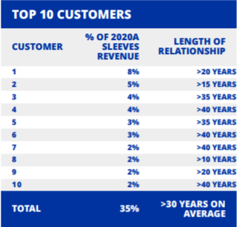
Diversified and loyal customer base: In the perspective of the larger packaging market, which is highly fragmented with numerous smaller competitors, such as the plastic packaging section, SIG has a significant size. This helps to reduce raw production cost and provide better service to consumers all around the world. SIG also secures long-term supply and service contracts for carton sleeves used in its equipment, with an average lifespan of six years. Sales of sleeves and closures account for over 90% of revenue, with the remainder coming from solutions such as filling lines and service. In 2020, none of SIG's clients will contribute for more than 10% of revenues, and the business's top ten customers will have been with the company for more than 10 years. They also have an astonishing 99% retention rate., implying the loyalty of their customer base.
Entrenched market position: SIG has a large regional footprint, and its recent growth, which included the acquisition of Visy Cartons in 2019 and the remaining 50% of its MEA joint venture in February 2021, is seen favorably since it strengthens the company's risk profile. SIG expects that Europe will contribute 36% of core revenue in 2020 (pro forma for the purchase of its MEA JV), while the MEA area will account for 15%. The Asia-Pacific area accounted for 33% of revenue, while the Americas region accounted for 16%.
Essential nature of the business operation and derived demand from the industries from essential product categories: The fact that product demand is less cyclical adds to the credibility of the assessment. The operations are necessary in nature, and the industry/product has drawn demand from necessity, resulting in a steady and rising demand.
In conclusion, the industry has low cyclicality and low volatility during economic cycles, which supports SIG's business risk profile. Furthermore, the sector is highly concentrated, with SIG controlling a substantial portion of the market. Furthermore, the company's seasoned market operations and established ties with important competitors are considered in the assessment. The foregoing analysis assures a solid market position with consistent and rising demand, as well as a long-term market position with low predicted volatility.
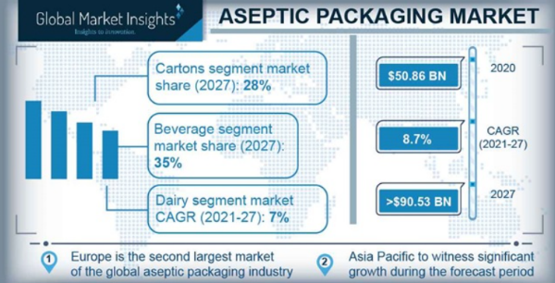
Industry Outlook: With a market valuation of USD 49.15 billion in 2020, the aseptic packaging market is expected to register a growth of 9.5% over the next 5 years and reach a market valuation of USD 72.15 billion. The key driver behind the growth of this industry is the requirement of high nutrient retention capacity and high product quality which is fulfilled by this product. It’s a strong substitute for preservatives and canning which helps in increasing the shelf life. The exhibit alongside shows an overview of the aseptic packaging market of which SIG is an integral part and key player.
Covid 19 has proved to be a boon for the sector which is witnessing considerable growth during the period. Infrequent lockdowns and associated concerns have led consumers to shift to online retailing’s and panic stockings thereby increasing the demand for milk and baby products. The concern for hygiene during the period is also evoking the inclination towards aseptic mode of packaging. These factors are expected to boost the demand for the products and bring about the required catalyst which will help in the next stage of revolution in the sector.
Financial Analysis:
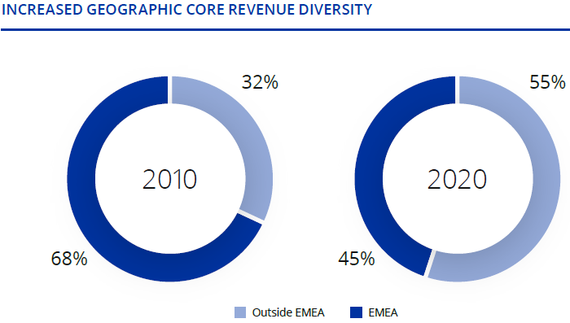
Low historical revenue growth but turning of tides - The topliner of the Company has been fluctuating. FY17 witnessed a slippage of 3.46% but since then the growth rate has been timid. In 2020, the revenue grew by 1.81% to € 1816.10 million. For FY21 however, the performance has improved considerably. The Q3’s core revenue at constant current was up by 14.7% post full consolidation of Middle East and Africa business post Feb 21. The growth for top line in FY21 has been delivered by Americas and APAC regions. Year 2020 and 2021 has seen an unexpected tailwind arising due to the Covid 19 scenario with intermittent imposition of lockdowns in all major markets that SIG caters to, stocking up of products coupled with increased home-based consumptions has provided the much-needed boost to the performance of the otherwise sluggish growth of the top line. Successful integration of Visy Cartons acquired in Nov 2019 assisted in improving the synergy across APAC regions. Geographical diversity in its topliner has been an additive factor in this improved growth story as depicted alongside. As per LTM sales will September 21, the Company has already registered a growth of 14.01% and RM 1912.90 on absolute basis.
Revival of Margins – The company had been in the red till as recent as 2018. However, with cost optimization measures, improved demand and softening of raw material prices, the profitability at all levels have shown improvements. For FY2020, the adjusted EBITDA stood up at € 498.3 million as against € 485.4 million in 2019. With improved 9 months performance till September 2020, the trend is expected to continue in a more vibrant manner. Prices of key inputs like Aluminium and polymers have softened and this assisted in positive impact on EBITDA. The Covid pandemic related restriction on movements have resulted in reduction of SG&A expenses like travels etc which has more than offset the increased employee costs. Europe too witnessed an increase in the demand for Cartons while the JVs in Middle East continues to be remunerative providing strong cash flows and stable dividend pay-outs. For FY21, the Last Twelve Months (LTM) net profit is considerably high at € 150 million and with an expected upswing in favourable fourth quarter coupled with festive season, the margins for FY21 are expected to be highest in the recent years.
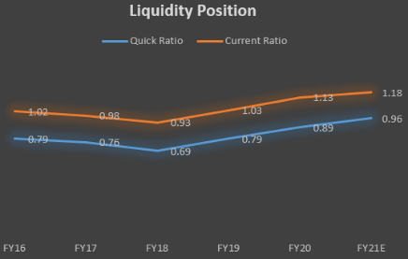
Improved Liquidity Position: Over the last two years, the cash flow position of the group as a whole has seen significant uptick. FY2020 has strong operating cash flows of € 425.8 million and free cash flow of € 223.20. The cash flow from operating actives have been positively impacted by the growth in EBITDA and improvement in Net Working Capital. The investing cash flows have been negatively impacted due to continued capex and investments. However, these investments and capex are expected to yield benefit in the long run. The Financing cash flows have been stable given the refinancing scheme undertaken by the group which has led to lower mandatory loan repayments during the last few quarters. In terms of ratio analysis too, critical ratios like current ratio and quick ratios have been showing improving trend as depicted alongside.
Leverage and Debt Refinancing: The strong cash inflows discussed above had a positive impact on the net debt position as well. The gross total debt for SIG stood at € 1697 as on Dec 2020 but with stronger cash and cash equivalents for the year, the net leverage ratio (net debt / Adj EBITDA) stood at 2.7x vis-à-vis 2.8x in 2019. The lease liabilities have increased during the year on account of new sleeves manufacturing facility being setup in China but the debt refinancing scheme entered into by the Company has brought in a considerable elbow room. As part of the refinancing scheme, two of the existing secured term loans have been replaced with new unsecured term loan and issuance of senior unsecured notes. New revolving credit facility has also been initiated to support the recent growth in the business demand. The debt rating for the group stands at investment grade of BBB- by S&P and Ba2 by Moody’s.
Valuations and Recommended investment action
This report has derived at the intrinsic value based on two different valuation models i.e.(I) DCF Valuation and (ii) Comparable Public Company Analysis
DCF Valuation:
The DCF analysis uncovers a marginally undervalued share with a considerable scope of further improvement provided the assumptions hold and the current uptrend continues for a near future. The DCF model of the firm resulted in an intrinsic price of CHF 27.80 as against the current prevailing market price of CHF 25 (as of trading day ended 1st Dec 21). There is an upside potential of 15% to CHF 30.79 with a limiting downside potential of CHF 22.76.
DCF Model – The model deployed in the extant case is a three-phase growth (in terms of topline) model. Given the availability of three quarter’s performance and considerable growth associated with it, we have used a different growth rate for FY2021 estimates. The fourth quarter of the financial year has been estimated to grow at a conservative rate of 10% on Y-o-Y basis. For the second transitionary phase, we have considered the top line to increase by a modest 6.50% assuming that the Covid pandemic will settle in, if not phased out by 2025. From FY25 onwards, the growth has been aligned with long term average GDP growth rate at 4% for Europe which is the largest market for the Company. Other key parameters of the income statement have been projected based on arithmetical average of the last 5 years’ percentage of sales method. The D&A as well as the capex are expected to replicate the past trends and have been assumed as a percentage of total asset base by employing vertical balance sheet method as underlying tool.
The WACC is a key input for the model and accordingly, following is the snapshot of the key variables for the same
ASSUMPTION | RATE | RATIONAL
Risk free rate | 1.0% | 10 Y Govt Bond Yield
Equity Risk Premium | 5.7% | Historical excess return
Beta | 0.91 | Avg raw beta using comparable
Cost of Equity | 6.19% | CAPM
Cost of Debt | 1.6% | Estimated from financial statement
Marginal Tax Rate | 25.27% | Latest year’s effective rate
WACC | 5.44% | Computation
Perpetual growth rate | 2.30% | Expected long term GDP growth rate

Sensitivity Analysis
This report also stresses upon the sensitivity analysis by checking the impact on market price per share as well as enterprise value upon impacts to WACC and terminal growth rate.
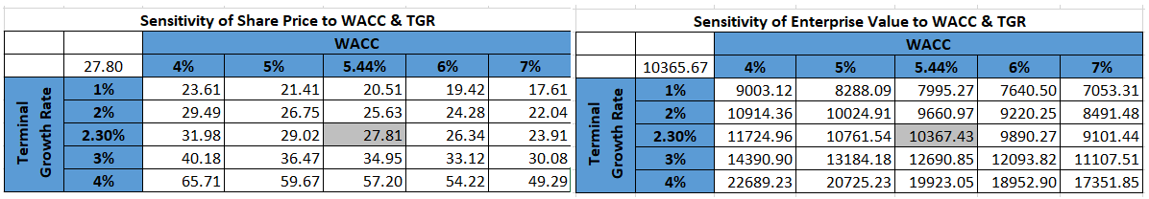
Based on the sensitivity analysis, it has been noted that terminal growth rate has a profound impact on both, share price as well as the overall enterprise value. The impact is more visible on the upper side of the spectrum as with 70 basis point of change in TGR, the share price fluctuates by 25% on the upper side and less than 8% on the lower side for the given level of WACC at 5.44%.
Comparable Public Company Analysis: For this, we assessed all the 9 public companies and computed a valuation of €6.5 billion (as per median) from EV/EBITDA multiple, €6.4 billion from EV/EBIT multiple and €3.3 billion from EV/Sales multiple. In the comparable company valuation of SIG, which is a capital-intensive company, we have preferred EV/EBITDA comparable for the firms traded on the market (public companies that have the most similar characteristics). There are a few outliers in the comp list of 9 companies (peer group information below), that is why we have preferred the median of the firms which resulted in EV/EBITDA multiple of 11.8x.
Investment Risks Assessment
The Company and the group per say are subjected to various types of risk factors which are discussed below
Market Risks
Any change in the market related parameters will have a bearing on the performance of SIG, financially as well as operationally.
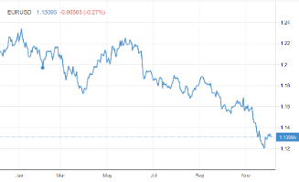
Currency Risk
SIG’s primary currency exposure is in relation to Euro denominated loan on intra group basis which is held by Swiss functional currency entity. Weakening of Euro even by 500 basis points will lead to an incremental exchange loss of € 14.1 million on unrealized basis. Further, while Euro is the presentation currency for the group, the revenue, expenses, asset and liabilities are present in other major currencies like US Dollar, Swiss Franc, Mexican Peso, Brazilian Real, Thai Bhat, New Zealand Dollar. This increases the translation risk.
Commodity Price Risk
The key purchases made by SIG includes aluminium and polymers. Changes in the price of these commodities cannot be easily transferred to the end users and this makes the Company vulnerable to fluctuation in price of the inputs. However, the group has taken adequate measures wherein 80% of the purchases are covered via financial hedge. As a practice, the group purchases its raw material in the spot market but uses derivatives to hedge the exposures. The strategy has been useful and hence the risk stands mitigated to a great extent.
Interest Rate Risk
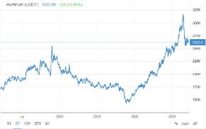
In June 2020, the group has entered into refinancing of its borrowings wherein the new term loans and the revolving credits have been availed at variable interest rate. As against this, the notes issued by the group are on fixed interest basis. This exposes the group to interest rate risks. However, the group have had profitable experience using interest rate swaps and it might renter into one in the event the yield trend reverses.
Credit Risk
The credit risk for the group arises out of the receivables from customers. However, historically, there has been no major write offs that could have impacted the going concern basis for the group. Further, as the Company is into food and beverages sector, Covid 19 did not had any detrimental impact on the realization front. To limit the risk factor further, the group follows a credit limit policy by virtue of which some advance payments are also taken against the sales made. With a diverse mix of regional, large national and international companies as client portfolio, the risk is further mitigated. The Treasury Policy of the Company restricts dealing with financial institutions with lower credit ratings.
Liquidity Risk
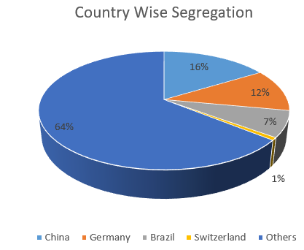
Increased leverage – As compared to the year 2016 and 2017, the financial leverage of the Company has been tamed from a high of 4.3x to the current leverage ratio of 2.55x. However, the refinancing executed in June 2020 is expected to increase the leverage levels. Adjusted Debt/EBITDA has increased folate to 3.54x as on 12/31/20. To mintage the matter, the group evaluates the cash and financial planning exercise on an ongoing basis. Further, it is undrawn multi-currency revolving credit facility which provides further elbow room.
Strategic Risks
Geographical Concentration – As of 2020, close to 57% of the top line was contributed by the EMEA region while another 38% of the top line was contributed by APAC region. This shows that while the group is conscious about diversification, there is still some way to go to reduce reliance on a particular region. On top of it, if country wise bifurcation is to be considered than 16% of the total sales as of 2020 was contributed by China alone. Refer the pie chart given alongside.

Product Concentration – The group falls under the industry classification of paper packaging and the main product is Aseptic Carton Packaging. The sub parts include Ascetic Carton Packaging filling machine, Aspectek Carton Packaging sleeves and closure, assembly service, machine’s spare parts, liquid and folding paper board. The subsidiary company i.e., Sig Combi bloc Obeisant Face also manufactures Sleeves. So overall, it’s the Aseptic Carton Packaging that the company caters to. While is a well-known brand and comes second only to Tetra Packaging but this product concertation exposes the risk of techno logical development. Aseptic Carton packaging replaced glass bottles and plastic packets as a technological revolution in the sector and the history may repeat itself with new innovative product rendering Aseptic carton packaging as an obsolete technology. Hence, product diversification should be a key strategy here.
Operational Risks
Lack of Growth Opportunity – As of December 2020, there were about 1266 SIG filling machines in the field spread over 60 countries. The Y-o-Y growth in the machine segment is only 3%. Of the total market share, close to 66% is dominated by Tetra and about 15% share is of smaller unorganized player. Hence, even thigh SIG comes as number two in the segment, there seems to be market concertation already. This limits the growth rate for the group which derives 86% of its revenue from the said product line.

Supply Chain Management – In 2019, the group had acquired 100% stake in Visy Cartons Pty Ltd to improve its manufacturing position in Australia and to realize synergy for its supply chain there. At the time when Covid 19 rendered supply chain and logistics solution of many companies useless, SIG was able to clock a jump in its performance aided by its strong supply chain management assisted by 600 service engineers worldwide.
Regulatory Risks
SIG caters to the food and beverage segment calling for high hygiene requirements. Further, it’s a listed Company which enters multiple M&A activities to enhance its footprints. This is coupled by the international presence from Asia Pacific to EMEA regions which leads to compliance of the strictest of laws overall. Such events expose the Company to regulatory risks

The risk assessment stands constrained on account of the following risks:
- The geographical concentration of revenue or within one activity like aseptic carton packaging systems,
- Risk of expansion in the new markets, which further carries risks in the establishment of supply chains, hiring of new personnel, regulatory & compliance issues, and competition in the new market.
- Execution & Consolidation risk, this is one of the biggest risks when a company does an acquisition, not only it put a huge financial burden on the acquiring company there is also an uncertainty on the synergies that can be achieved.
- Increasing leverage levels of the Company (Adj Debt/ EBITDA) increased to 3.54x as of 12/31/20),
- Majority of operations in mature markets, growth prospects are constrained,
- The Company’s profit margins are affected from raw material price movements and cost inflation,

- Adverse exchange rate movements in CHF vs other currencies.
However, investment risk assessment derives strengths from its strong market position, long-term contracts in place with some large customers, investment-grade credit rating, moderate capital structure, solid liquidity position and experienced management team.

SIG’s Final Rating:
Environmental, Social & Governance (ESG)
Overview
SIG Combibloc Group AG considers ESG issues to be particularly important and has therefore decided to increase its transparency regarding its goals by releasing a "corporate responsibility report" for the first time in 2020. Our ESG analysis of SIG is primarily based on the targets set by the company and the data collected on the REFINITV WORKSPACE platform. According to the data collected, SIG improved its ESG-related performance from a score of 67.07 in 2019 to 74.86 in 2020, with a grade of B+. In contrast, the company's average over the past five years is 69.69. to date. The score consists of three main Pillars each with their own specific weight on the total tally based on their relative importance to SIG's business. The pillars are Environmental, Social and Governance that have weights of 36.27%, 40.08%, and 23.65% respectively in the calculation of the ESG score. Also playing an important role is the controversies pillar, which is divided into Emissions, Resource Use Score and Environmental Innovations. We have also compared SIG with our peers regarding ESG score. SIG is above average compared to its peers in all pillars, except the Social Pillar, and has the best score for Resource Use.
Environmental
SIG has announced its ambitious program called WAY BEYOND GOOD. The company is putting sustainability and responsibility at the center by working toward a carbon reduction goal in line with the latest 1.5°C climate science. SIG Combi bloc’s vision is to protect, maintain and promote biodiversity for future generations and ensure the safe distribution of nutrition and hydration, as described in the "corporate responsibility report" published in 2020. For 2030, they have set a target to cut the carbon footprint of their operation by 60% and reduce the value chain footprint per liter packed by 25%. Accordingly, on the REFINITIV work area, the environmental pillar score is 87.25 for a grade of A. This pillar consists of 3 main areas: Resource Use, Emissions, and Env. Innovation. Resource Use recorded an ESG score of 99.04 and demonstrates the company's commitment to its sustainability goals.
SIG implemented a number of innovations in 2020 to decrease energy and water consumption for its filling machines. In its 2020 annual report, SIG stated that these innovations resulted in a 50 percent reduction in water consumption and an 85 percent reduction in energy used. SIG has the best result for Waste Recycled-To-Total Waste with an outstanding 99.40%. Total direct and indirect energy consumption in gigajoules in 2020 is 1,198,800 of which 62.38% renewable energy sources. In its report, SIG announced its plan to increase the use of renewable energy to meet its consumption, including beginning a series of investments to install photovoltaic panels in its facilities. Emissions recorded an A- grade on REFINITV. The company has set as one of its goals to reduce its Scope 1,2 and 3 emissions by 25% by 2030. However, SIG is already considered one of the best in the benchmark on the Total CO2 Emissions/Million Revenue ratio and has improved steadily since 2018. However, compared to its peers, SIG performed poorly with respect to Total Waste in tons/ Million in Revenues with a result of 23.94. SIG also has the best result for recycled waste to total waste with an outstanding 99.40%. The Env. Innovation mark is A, as SIG is at the forefront of eco-design products.
Social
SIG ESG's ESG Social Pillar in 2020 was 54.86 for a grade mark of B-. The Social Pillar is the area in which the company performed worst. SIG significantly improved its score on the Workforce sector from 36.11 to 84.55 points. However, the Human Rights sector is considerably underperforming and has also worsened since 2019. SIG in its Corporate Responsibility Report announced its firm policy in ensuring existential human rights but in fact is still particularly exposed to issues such as Child and Forced Labor, especially inherent to its suppliers. Other aspects of the Social Pillar in which SIG is in deficit are the Salary Gap, which divides the CEO's salary for the average employee's salary, and the Women Employees and Managers. In this regard, the addition to the Group Executive Board of José Matthijses may represent an attempt to reverse course. In fact, SIG has announced its goal to increase the number of women employed in management and leadership positions to 30% by 2025. Currently, the number of women employed by SIG is only 19% of total employees.
Governance
The shares of SIG Combibloc Group AG are listed on SIX Swiss Exchange (symbol: SIGN). As of December 1, 2021, the market capitalization was CHF 8,410 million and the share price was 24.92
The company is subject to and complies with Swiss regulations and laws.
The Board of Directors is responsible for the control and conduct of the company's business. The Board establishes the objectives of the company and the strategy to achieve them. The bylaws state that the Board must consist of at least 3 members including the Chairman of the Board. Currently, the Board consists of seven members who are individually elected each year for a one-year term and may be re-elected without limit. The number of outside terms each Council member may have been set by the bylaws of the corporation. The three standing committees of the Board are: the Nominating and Governance Committee, the Compensation Committee and the Audit and Risk Committee. The latter two must consist of at least three members, while the Nominating and Governance Committee may consist of two or more members, and a chairman must be appointed for all. Swiss law requires that each member of the Compensation Committee must be elected annually by the Annual General Meeting. No member of the Board of Directors covers an executive role. The Board must meet at least four times a year (in 2020 there were 6 meetings) and must supervise the Group Executive Committee. The Group Executive Committee is headed by the CEO and consists of six members. The CEO doesn’t chair the Board. The company completed a transition in the CEO position, replacing the outgoing Rolf Stango with Samuel Siegrist, who previously served as CFO. Rolf Stango served as CEO from 2008 to 2020. The change can be interpreted as a positive catalyst to renew senior management and address the future. The Board of Directors has two women as members, while the Group Executive Board has only one in 2021. The Board of Directors is authorized to increase the share capital by up to CHF 640,106.48 until April 7, 2022. In addition to the Performance Share Unit and Restricted Share Unit plan as an incentive, the Company introduced an equity investment plan (EIP) in 2020 for employees in management positions who could invest in shares of the Company. As of December 31, 2020, shareholders holding more than 3% of the Company's stock are as follows:
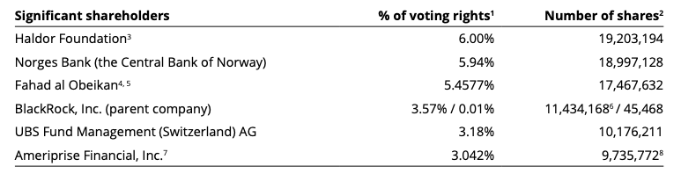
The Company has announced on 24 November 2020 that it entered in an agreement to purchase the remaining shares in its joint venture in Saudi Arabia and in UAE from Obeikan Investment Group which in turn will end up owning a stake in SIG of around 5.175% of the share capital. The ESG score in Governance of SIG Combibloc Group AG is equal to 90 and a grade mark of A.
Images
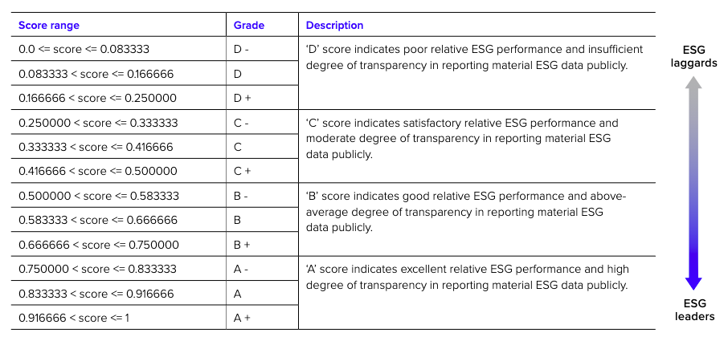
Images
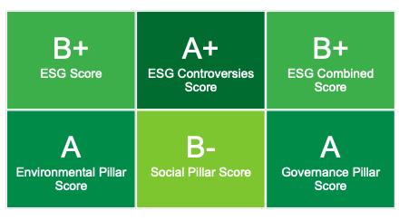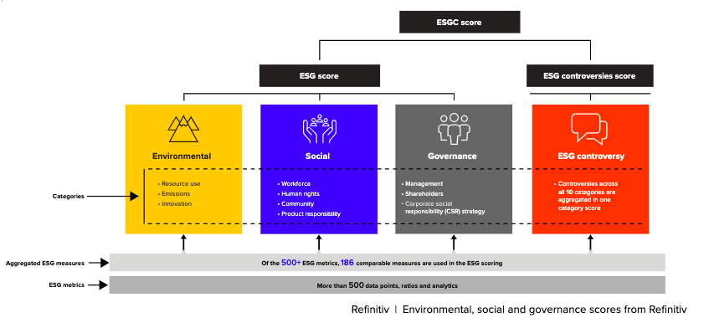
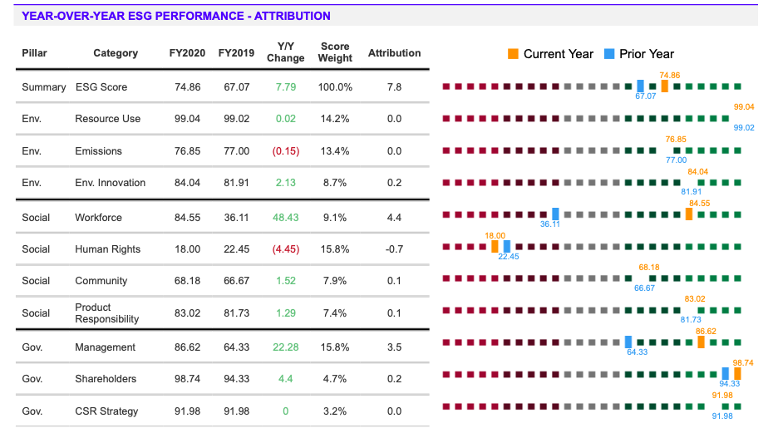

SIG ESG Key Parameters and Risk Assessment:
Environment Risk Profile: SIG is moderately exposed to environmental risks such as increasing regulation of carbon emissions, water management and waste and pollution. The company has made evident progress in mitigating these risks by establishing clear targets for reducing emissions and water use, as well as developing sustainable products and supporting recycling programs. SIG has limited exposure to physical climate risk and continues to make progress towards targets on carbon transition in line with Science Based Targets initiative.

Social Risk Profile: SIG is moderately exposed to social risks such as consumer attitudes towards recycling, as well as health and safety and responsible production. SIG has mitigated these risks with 100% recyclable products, 100% of suppliers with contractual social responsibility requirements, as well as a declining lost time case rate which halved between 2016 and 2020, although it has been volatile. In addition, all SIG plants are SEDEX/SMETA audited and its products help to provide safe and affordable nutrition to consumers around the world in a sustainable way.

Governance Risk Profile: SIG’s governance issuer profile score is moderately negative but on an improving trend. SIG has been a listed company since 2018 and has increased its free float with the exit of the lead shareholder (elimination key man risks); the company has also accomplished an orderly senior management transition in 2020. Since IPO, SIG has performed in line with expectations. The company has established a medium-term leverage target; however, it may take some time to achieve.

Outlook: SIG’s ESG rating is assessed as “Positive” given the company’s commitment toward enhancing its operation and practices, which is evident by the year and year improvement in the parameters. The company’s stated 2025 goals are clear and attainable which further enhances SIG’s ESG assessment.

References
https://www.marketscreener.com/quote/stock/SIG-COMBIBLOC-GROUP-AG-46388822/financials/

https://finance.yahoo.com/quote/SIGN.SW/key-statistics?p=SIGN.SW

https://www.fortunebusinessinsights.com/industry-reports/food-packaging-market-101941
https://www.moodys.com/
https://www.gminsights.com/industry-analysis/aseptic-packaging-market

